Part B : Sample

Between 1945 and 1960, Quebec was under the leadership of the Union Nationale. This government had specific economic and political characteristics.

Describe the political and social aspects of Quebec society between 1945-1960

Procedure:
Consult the document file.
Select only those documents that relate to the time period and government policies in question.
Complete the diagram in the answer section using the documents you have selected.

Answer Section Part B

Name of the Leader of the Union Nationale in this time period.
_____________________________________
Topic of Description

Central Elements

First Connection: Economics
Main Economic Theory
______________________

Exploitation of resources
________________________

________________________
Modernization of Agriculture
________________________

________________________

Second Connection: Political
Federal/Provincial Relationships
_______________________

_______________________

Step toward economic independence
________________________

________________________

Nationalism
________________________

________________________

Document File:
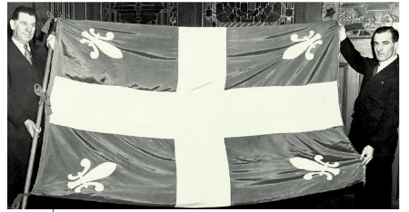
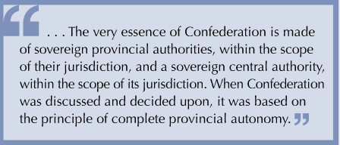
1
2

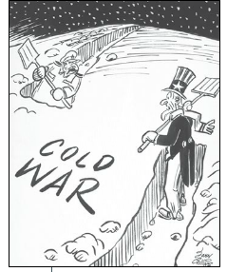
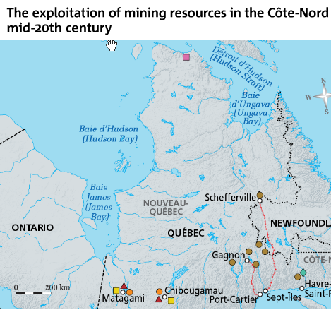
4
3

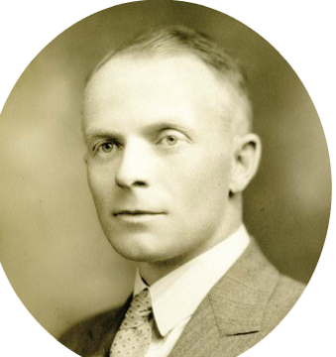
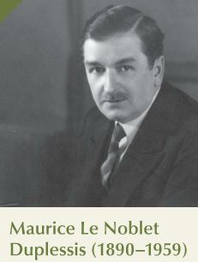
6
Adelard Godbout
5

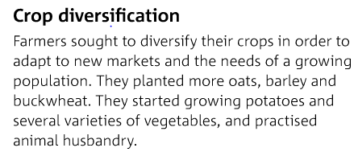
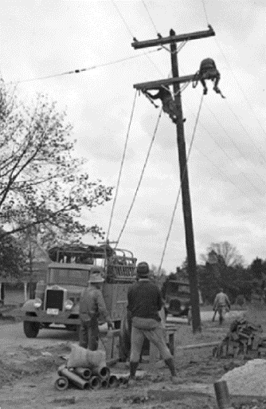
8
Rural electrification
7

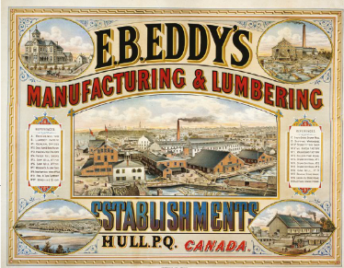
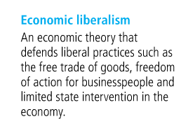
10
9

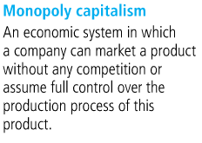
12
11

