Name:  Group:  Date:



**EVALUATION OF COMPETENCIES (*cont.*) Worksheet 3.15-EV**

**DOCUMENTS – SECTION C**

DOCUMENT

**2**

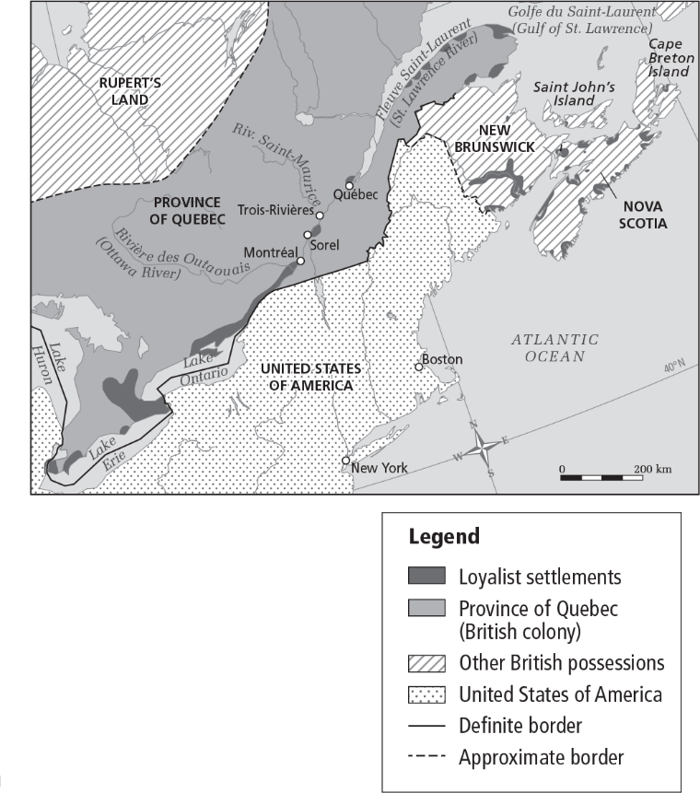

DOCUMENT

**1**

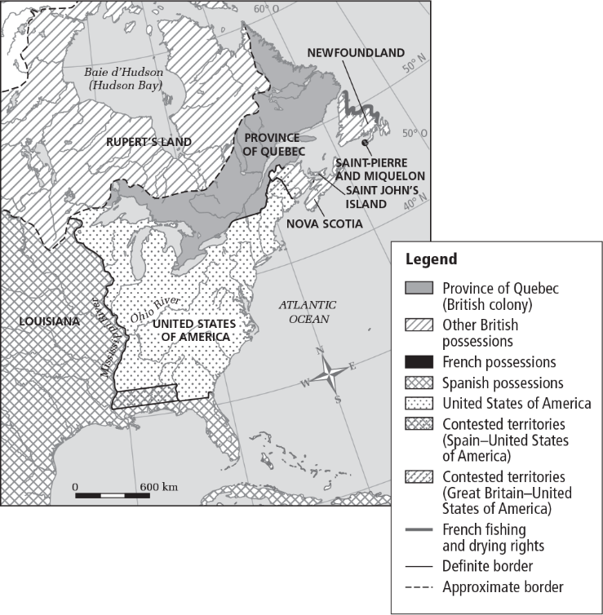

DOCUMENT

**4**



A group of English, Scottish and *Canadien* merchants from Montréal . . . formed a partnership, which became the North West Company in 1783. With the Treaty of Paris of 1783, fur traders from Montréal lost the territory south of the Great Lakes. As a result, they had to redirect their trade network toward the northwest, which was still under British control, but outside the Province of Quebec. Despite this change, the fur trade remained one of the colony’s main economic activities. 

Campeau, Lavoie, Fortin and Parent, *Reflections.qc.ca*, Secondary III, 2018.



The American War of Independence ended in 1783 and helped the Anglophone Canadian population strengthen its numbers with the arrival of   
40 000 to 50 000 Loyalists who wished to remain British subjects and settled in the Maritime provinces (particularly in Nova Scotia) throughout the 1780s and, to a lesser extent, in the Province of Quebec. 

Jean-Michel Lacroix, *Histoire du Canada, Des origines à nos jours*

[History of Canada, Origins to Our Times], 2016 [translation].

DOCUMENT

**3**

Name:  Group:  Date:



**EVALUATION OF COMPETENCIES (*cont.*) Worksheet 3.15-EV**

DOCUMENT

**56**

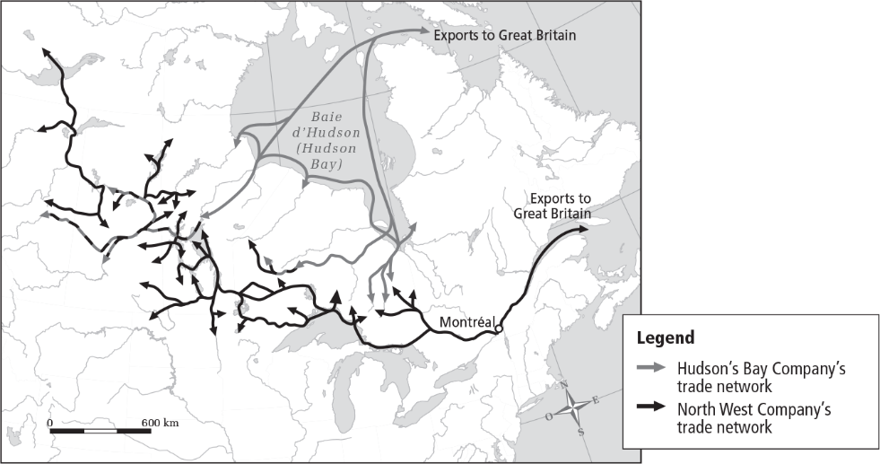



Data from: CEFAN, 2014, and Library and Archives Canada, 2014.

DOCUMENT

**7**

**Changes in the proportion of British colonists in the colony**

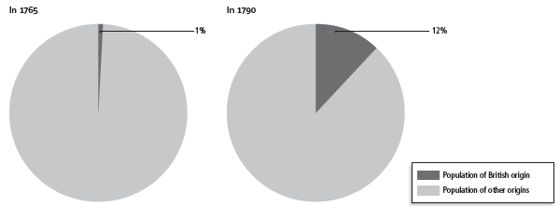

DOCUMENT

**68**

Dickinson and Young, *A Short History of Quebec*, 2014.

The American colonies were granted independence . . . . With the creation of the United States, Quebec lost its territory south of the Great Lakes, although Canadian merchants continued to trade in the area until the end of the century. Britain, did, however, keep the richest fur-trading areas in the northwest, and many traders moved north from Albany to Montreal. 

Name:  Group:  Date:



**EVALUATION OF COMPETENCIES (*cont.*) Worksheet 3.15-EV**

**QUESTION**

**CRITERION 4: Rigour of the interpretation**

1. Tense relations between the British mother country and the Thirteen Colonies led to a key event in this period, the American Revolution (1775–1783). This event had major consequences for the Province of Quebec.

The American Revolution

**Explain the changes that occurred in the Province of Quebec following the American Revolution (1775–1783).**

A demographic change

An economic change

In your text, you must:

* indicate a demographic change and explain why it occurred
* indicate an economic change and explain why it occurred

Steps:

* Consult the documents on pages D3-77 and D3-78.
* Complete the diagram on the next page.
* Write a text of approximately 150 words at the bottom of the next page.

Note: Only the text will be graded.

|  |  |  |  |  |  |  |  |
| --- | --- | --- | --- | --- | --- | --- | --- |
|  | **Indicates the elements of the answer** | | | **Supports the elements of the answer  with facts** | | |  |
| **First element of the answer** | The student  indicates the  element of  the answer | correctly. | 2 marks | The student supports the element of the answer | appropriately. | 2 marks | **/4** |
| more or less  appropriately. | 1 mark |
| more or less  correctly. | 1 mark | inappropriately. | 0 marks |
| The student  indicates the  element of the  answer incorrectly  or does not  indicate it. |  | 0 marks | The student  presents  information  that is | accurate and  relevant. | 1 mark |
|  | inaccurate. | 0 marks |
| **Second**  **element of**  **the answer** | The student  indicates the  element of the  answer | correctly. | 2 marks | The student  supports the  element of the  answer | appropriately. | 2 marks | **/4** |
| more or less  appropriately. | 1 mark |
| more or less  correctly. | 1 mark | inappropriately. | 0 marks |
| The student  indicates the  element of the  answer incorrectly  or does not  indicate it. |  | 0 marks | The student  presents  information  that is | accurate and  relevant. | 1 mark |
|  | inaccurate. | 0 marks |
| **Total** | | | | | | | **/8** |

Name:  Group:  Date:



**EVALUATION OF COMPETENCIES (*cont.*) Worksheet 3.15-EV**

**Explain the changes that occurred in the Province of Quebec following the American Revolution (1775–1783).**

**Diagram**

|  |  |  |
| --- | --- | --- |
| **Indicate a demographic change.** |  | **Indicate an economic change.** |
|  |  |  |
| **Explain why this occurred.** |  | **Explain why this occurred.** |
|  |  |  |

**Text**