Name:  Group:  Date:



**EVALUATION OF COMPETENCIES (*cont.*) Worksheet 3.15-EV**

**DOCUMENTS – SECTION B**



DOCUMENT

**1**

And to the End that the Church of England [Anglican Church] may be established both in Principle and Practice, and that the said Inhabitants may by degrees be induced [led] to embrace [adopt] the Protestant Religion, and their Children be brought up in the principles of it; We do hereby declare it to be Our Intention . . . [that] all possible encouragement shall be given to the erecting of Protestant schools . . . . 

George III, *Instructions to Our Trusty and Wellbeloved*

*James Murray . . . Our Captain General and Governor*

*in Chief in and over Our Province of Quebec . . . , the*

*Seventh Day of December 1763 in the Fourth Year*

*of Our Reign.*

DOCUMENT

**Monseigneur Jean-Olivier Briand (1715–1794)**

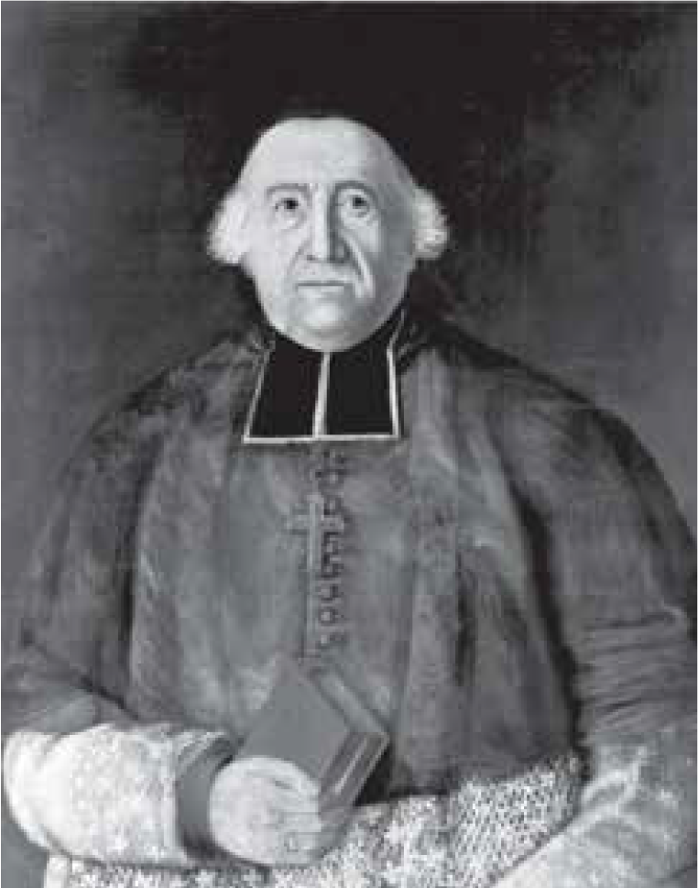

**2**



DOCUMENT

**5**

Jean-Michel Lacroix, *Histoire du Canada, Des origines*

*à nos jours* [History of Canada, Origins to Our Times],

2016 [translation].

The *Quebec Act* of 1774 restored Catholics’ right of access to official positions, introduced British criminal law while maintaining French civil law and legalized the seigneurial system. The government was aided by a legislative council of 17 to 23 members chosen by the colonial authorities . . . and open to French Canadian seigneurs, on condition that they constituted a minority of members. 

DOCUMENT

**4**



Horguelin, Ladouceur, Lord and Rose, *Panoramas*, 2010

.

The Conquest of New France by the British in 1760 suspended French immigration. . . . From 1760 to 1775, few new British colonists settled in the colony, and those that did were mainly members of the elite: colonial administrators, military officers and merchants. 

DOCUMENT

**3**

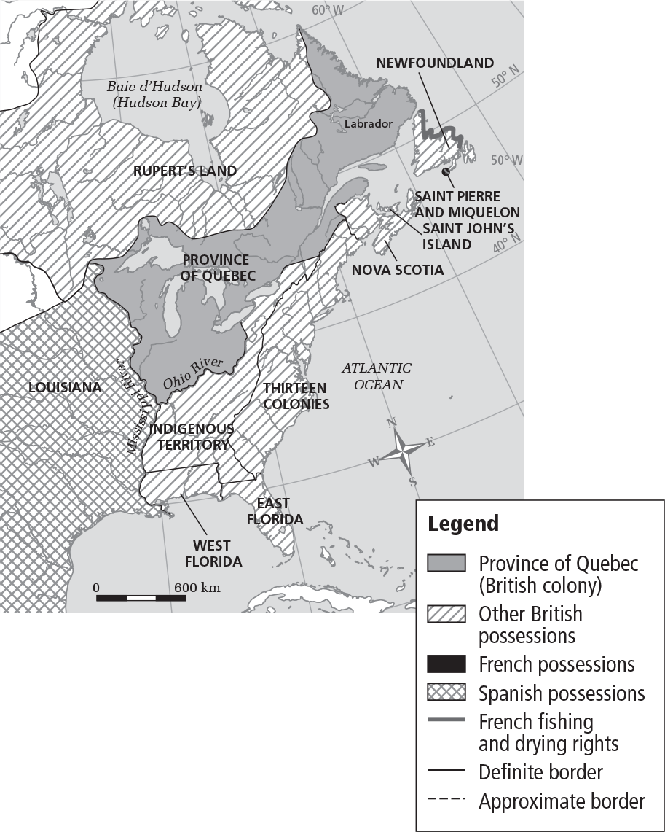

Name:  Group:  Date:



**EVALUATION OF COMPETENCIES (*cont.*) Worksheet 3.15-EV**

DOCUMENT

**6**



The first British people to settle in the province were the merchants, the majority of which were from the Thirteen Colonies. It is estimated that in 1763 there were about 300 inhabitants of British origin in the colony, not including soldiers. 

Fortin, Ladouceur, Larose and Rose, *Panoramas*, 2009.

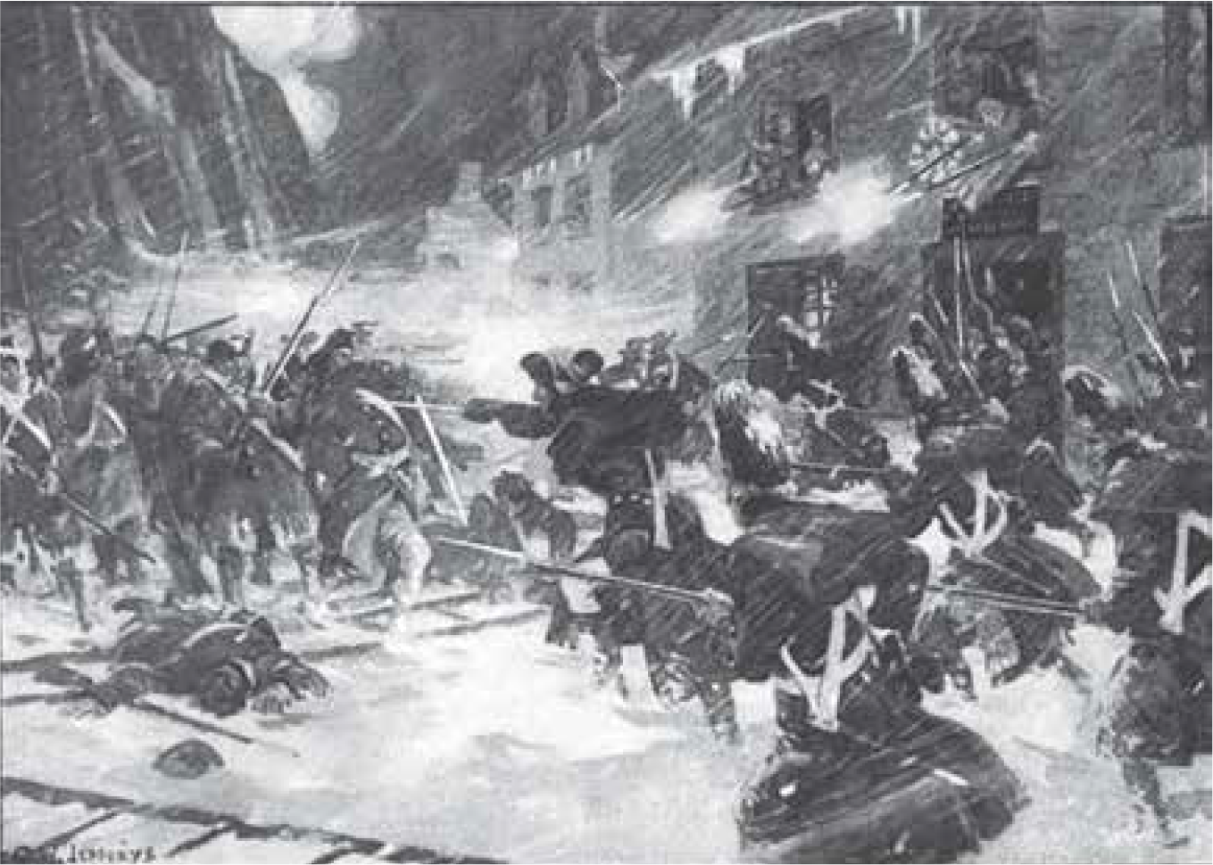

DOCUMENT

**8**

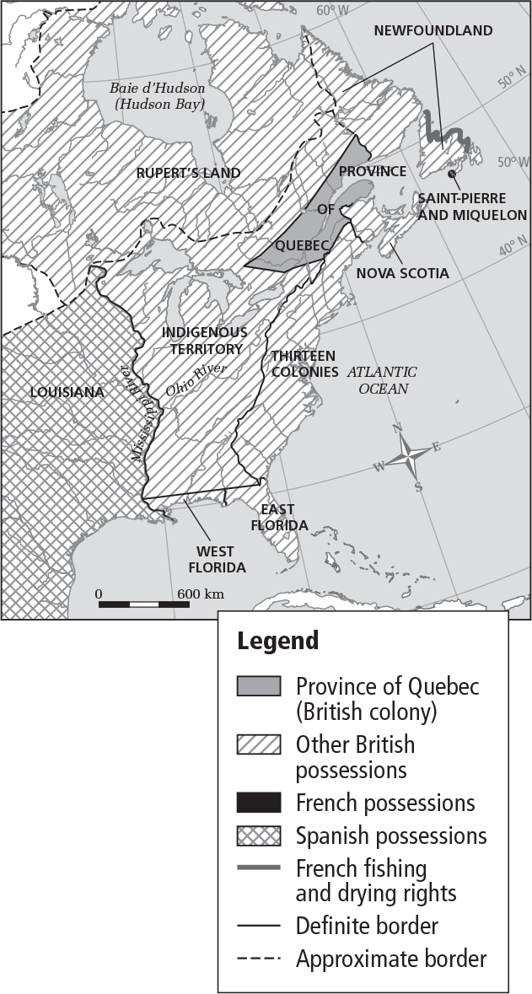

DOCUMENT

**9**

Because the British assumption of the same international sovereignty over the First Nations was obviously of a greater threat to the First Nations, it was contested in 1763 by Pontiac’s Rebellion . . . . As a result, several months later, the Proclamation of 1763 reserved the western territory for its Native occupants . . . thereby preventing the incursion of English-speaking occupants. 

Gossage and Little, *An Illustrated History of Quebec: Tradition and Modernity*, 2015.

Charles William Jefferys, 1916.

DOCUMENT

**7**

**The attack on the city of Québec during the American Revolution**

Name:  Group:  Date:



**EVALUATION OF COMPETENCIES (*cont.*) Worksheet 3.15-EV**

**QUESTION**

**CRITERION 3: Coherent representation of a period in the history of Québec and Canada**

1. Between 1763 and 1775, colonial society had distinctive territorial and cultural features.

**Describe colonial society between 1763 and 1775 from a territorial and cultural perspective.**

Steps:

* Consult the documents on pages D3-73 and D3-74.
* Select only those documents that relate to the period and territory concerned.
* Complete the diagram on the next page using the documents you have selected.

|  |  |  |  |  |  |  |  |
| --- | --- | --- | --- | --- | --- | --- | --- |
| **Indicate the topic of description** | | | | | | | |
| The student indicates the topic  of description correctly. | | The student indicates the topic of description more or less correctly. | | | The student indicates the topic of description incorrectly or does not indicate it. | | **/2** |
| 2 marks | | 1 mark | | | 0 marks | |
| **Provide details on connected elements** | | | | | | | |
| **First connection** | The student provides details on the central element.* | | 1 mark | The student provides details on the other two elements. | | 2 marks | **/3** |
| The student provides details on only one of the other two elements. | | 1 mark |
| The student does not provide details on the other two elements. | | 0 marks |
| The student does not provide details on the central element. | | 0 marks | The student provides details on the other two elements. | | 1 mark |
| The student provides details on only one of the other two elements or does not provide any details. | | 0 marks |
| **Second connection** | The student provides details on the central element. | | 1 mark | The student provides details on the other two elements. | | 2 marks | **/3** |
| The student provides details on only one of the other two elements. | | 1 mark |
| The student does not provide details on the other two elements. | | 0 marks |
| The student does not provide details on the central element. | | 0 marks | The student provides details on the other two elements. | | 1 mark |
| The student provides details on only one of the other two elements or does not provide any details. | | 0 marks |
| **Total** | | | | | | | **/8** |

* If the student does not provide information on the central element, the student cannot obtain more than 1 mark.

Name:   Group:   Date:

**EVALUATION OF COMPETENCIES (*cont.*) Worksheet 3.15-EV**



**Describe colonial society between 1763 and 1775 from a territorial and cultural perspective.**

Complete the diagram below.

Topic

**CENTRAL ELEMENT**

**CENTRAL ELEMENT**

|  |
| --- |
| **Religion of the majority**  **of these colonists** |
|  |

|  |
| --- |
| **Language spoken**  **by these colonists** |
|  |

Second connection

|  |
| --- |
| **Country of origin of the new**  **colonists, who settled in the**  **colony during this period**  **and were few in number** |
|  |

First connection

|  |
| --- |
| **A region added to the colony’s territory with the second constitution in 1774** |
|  |

|  |
| --- |
| **Region included in the colony’s territory between 1763 and 1774** |
|  |

|  |
| --- |
| **First constitution that established the colony’s territory** |
|  |

|  |
| --- |
| **Name of the colony with a Francophone**  **Catholic majority in this period** |
|  |