Name:  Group:  Date:



**EVALUATION OF COMPETENCIES (*cont.*) Worksheet 3.15-EV**

**DOCUMENTS– SECTION C**

DOCUMENT

**2**

**The cost of health care, 1961 and 1966**

DOCUMENT

**1**

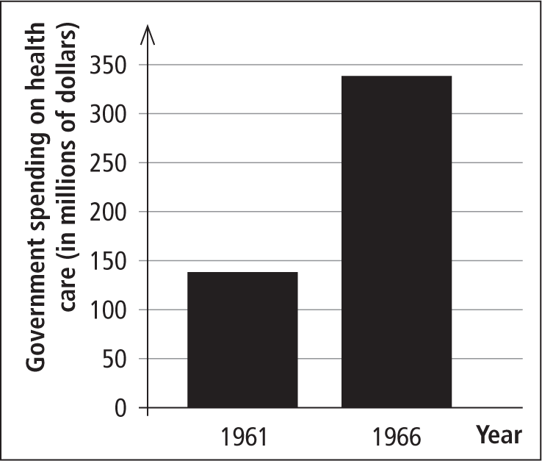

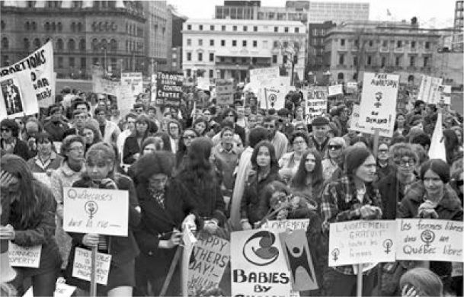

DOCUMENT

**3**

**Human life**

DOCUMENT

**4**

**The vitality of student movements in the 1960s**

. . . We wanted to protest against everything—poverty, capitalism, all forms of injustice, discrimination [and] exploitation. . . . 

Excerpt from testimony by Lise Balcer, fall 1968 [translation].

Official logo adopted by the *Régie de l’assurance maladie du Québec*

DOCUMENT

**5**

Excerpt from: Encyclical Letter, *Humanae Vitae, of the*

*Supreme Pontiff Paul VI on the Regulation of Birth,* 1968.

. . . We base our words on the first principles of a human and Christian doctrine of marriage when we are obliged once more to declare that the direct interruption of the generative [reproductive] process already begun and, above all, all direct abortion, even for therapeutic reasons, are to be absolutely excluded as lawful means of regulating the number of children. . . . 

**The right to abortion**

Data from: Paul-André Linteau et al.,

*Histoire du Québec contemporain,* vol. 2,

*Le Québec depuis 1930,* 1989.

Name:  Group:  Date:



**EVALUATION OF COMPETENCIES (*cont.*) Worksheet 3.15-EV**

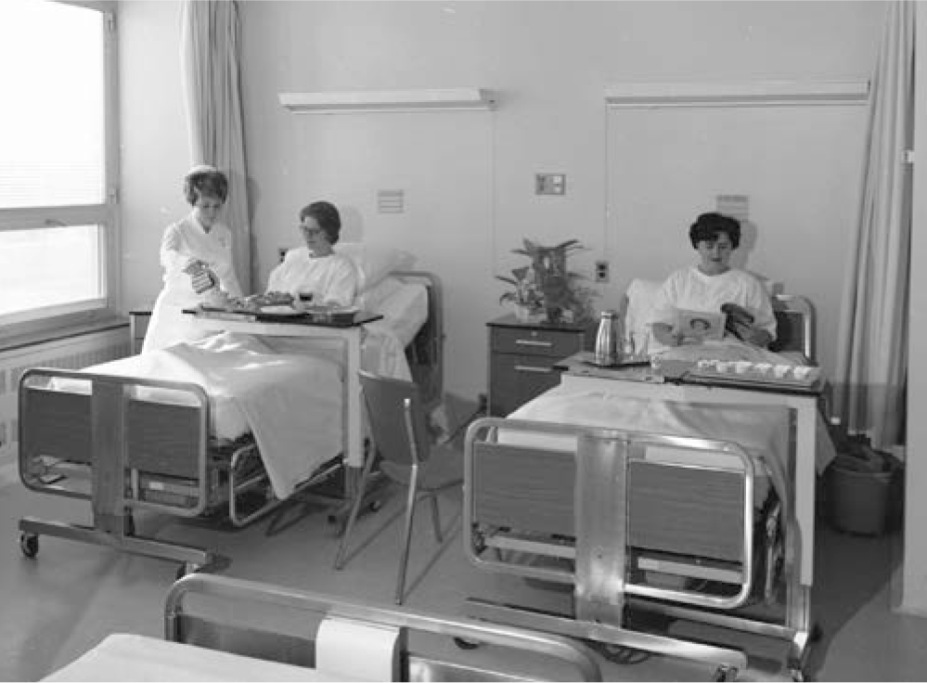

DOCUMENT

**7**

**Université du Québec à Rimouski, 1973**

DOCUMENT

**6**

**Patients at Hôpital du Sacré-Cœur, 1966**

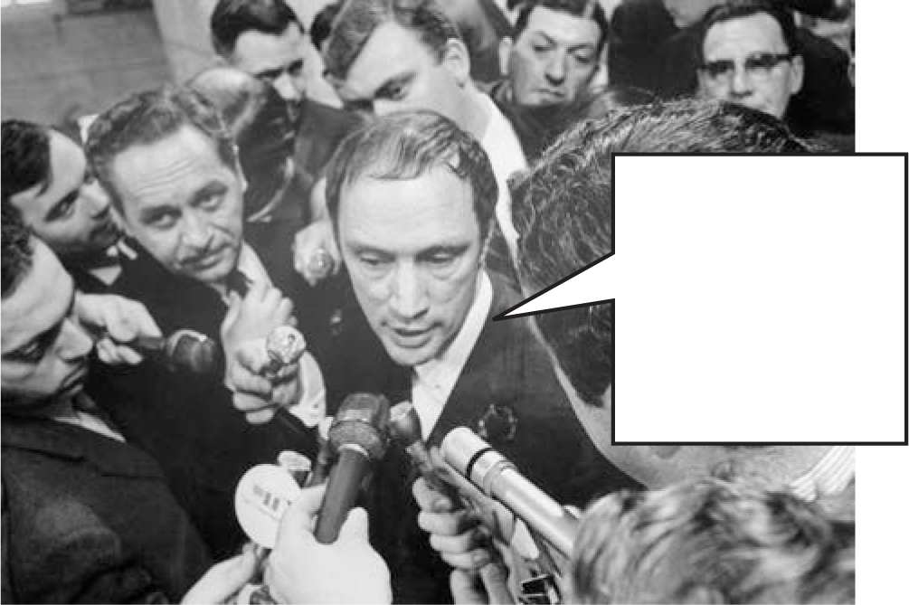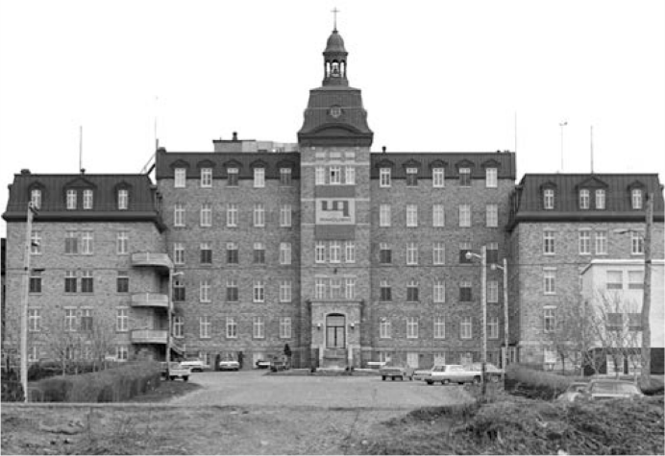

DOCUMENT

**10**

**The goal of democratization**

Bilan du siècle [Review of the Century],

University of Sherbrooke, 2018 [translation].

“There’s no place for the state in the bedrooms of the nation.”

1964 – Liberal Minister Claire Kirkland-Casgrain passed Bill 16 in the Legislative Assembly, which made important amendments to the *Civil Code*.

The changes brought by the *Act Respecting the Legal Capacity of Married Women* gave women the full legal capacity to practise a profession and to manage their own property. 

The modern conviction that everyone has a right to schooling makes it essential that education be available to all children, without regard to class, race or belief, from the primary grades to the university. No longer is education the privilege of an elite. Free instruction is essential to make education universal, yet modern education needs (laboratories, libraries, teacher training, research, etc.) have made the cost of education soar. . . . There is still a need, however, to convince everyone that the expenses of education are a sound social and economic investment. 

Excerpt from: *Report of the Royal Commission of Inquiry on Education in the Province of Quebec,* 1963.

DOCUMENT

**97**

DOCUMENT

**8**

Name:  Group:  Date:



**EVALUATION OF COMPETENCIES (*cont.*) Worksheet 3.15-EV**

**QUESTION**

**CRITERION 4: Rigour of the interpretation**

1. During the Quiet Revolution and the years that followed, major changes occurred in Québec: values and attitudes evolved at a time when the social role of the state was undergoing significant change.

The Quiet Revolution and  
the years that followed

**Explain the changes that occurred in Québec during the Quiet Revolution and the years that followed.**

Change in the social role of the state

Change in Quebecers’ customs and values

In your text, you must:

* indicate a change in Quebecers’ customs and values and use facts to illustrate it
* indicate a change in the social role of the state and use facts to explain it

Steps:

* Consult the documents on pages D3-84 and D3-85.
* Complete the diagram on the next page.
* Write a text of approximately 150 words at the bottom of the next page.

Note: Only the text will be graded.

|  |  |  |  |  |  |  |  |
| --- | --- | --- | --- | --- | --- | --- | --- |
|  | **Indicates the elements of the answer** | | | **Supports the elements**  **of the answer with facts** | | |  |
| **First element of the answer** | The student indicates the element of the answer | correctly. | 2 marks | The student supports the element of the answer | appropriately. | 2 marks | **/4** |
| more or less appropriately. | 1 mark |
| more or less correctly. | 1 mark | inappropriately. | 0 marks |
| The student indicates the element of the answer incorrectly or does not indicate it. |  | 0 marks | The student presents information that is | accurate and relevant. | 1 mark |
|  | inaccurate. | 0 marks |
| **Second element of the answer** | The student indicates the element of the answer | correctly. | 2 marks | The student supports the element of the answer | appropriately. | 2 marks | **/4** |
| more or less appropriately. | 1 mark |
| more or less correctly. | 1 mark | inappropriately. | 0 marks |
| The student indicates the element of the answer incorrectly or does not indicate it. |  | 0 marks | The student presents information that is | accurate and relevant. | 1 mark |
|  | inaccurate. | 0 marks |
| **Total** | | | | | | | **/8** |

Name:  Group:  Date:



**EVALUATION OF COMPETENCIES (*cont.*) Worksheet 3.15-EV**

**Explain the changes that occurred in Québec during the Quiet Revolution and the years that followed.**

**Diagram**

|  |  |  |
| --- | --- | --- |
| **Indicate a change in Quebecers’ customs and values.** |  | **Indicate a change in the role of the state.** |
|  |  |  |
| **Use facts to illustrate this change.** |  | **Use facts to explain this change.** |
|  |  |  |

**Text**